Jeremy Scheuerman

Cosc 120

Dr. Peter Wang

Lab 4

4.1

1. 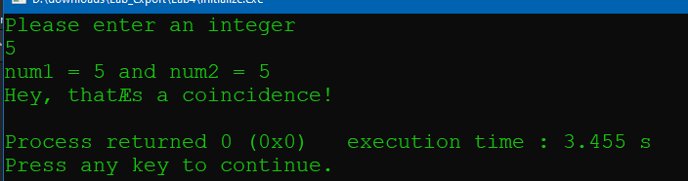

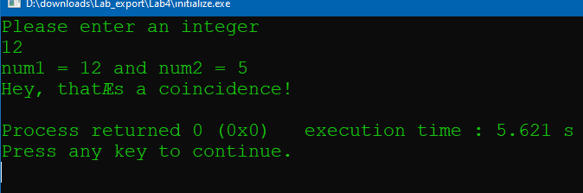

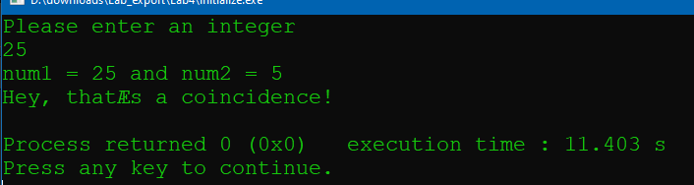

Num 2 is defined as a literal and there is a print formatting issue as well in the line below it

2. 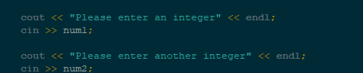

3. 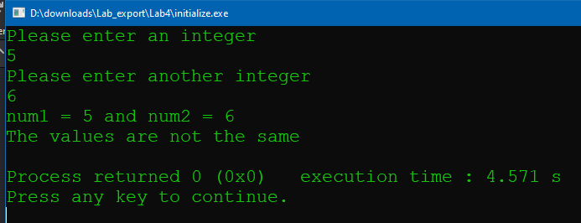

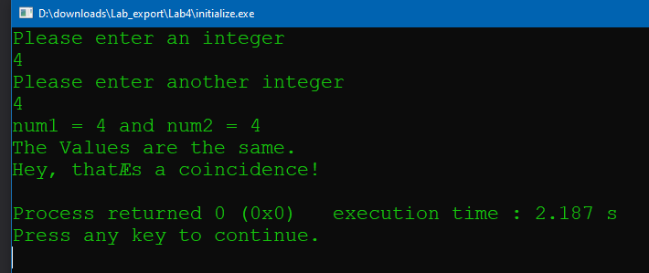

4. 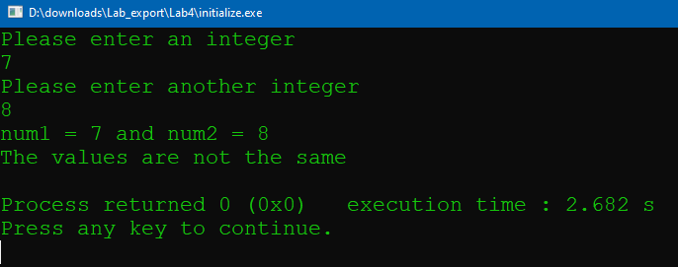

Source code

// This program tests whether or not an initialized value

// is equal to a value input by the user

// PLACE YOUR NAME HERE

#include <iostream>

using namespace std;

int main()

{

int num1,num2; // num1 is not initialized

cout << "Please enter an integer" << endl;

cin >> num1;

cout << "Please enter another integer" << endl;

cin >> num2;

cout << "num1 = " << num1 << " and num2 = " << num2 << endl;

if (num1 == num2)

cout << "The Values are the same.\nHey, that’s a coincidence!" << endl;

else

cout << "The values are not the same" << endl;

return 0;

}

4.2

1. 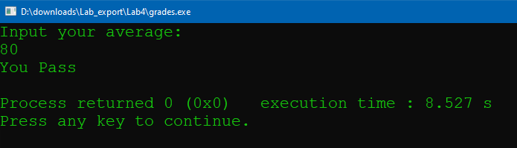

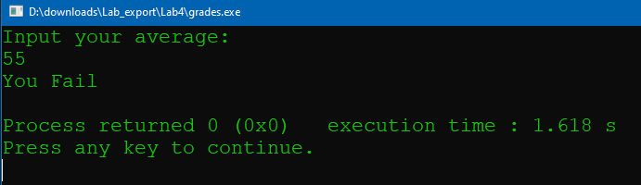

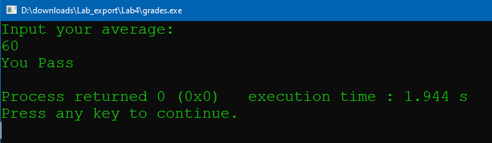

2.

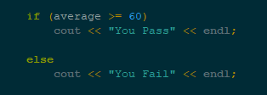

3. 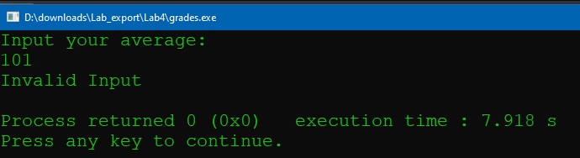

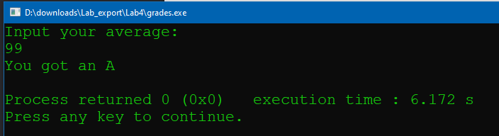

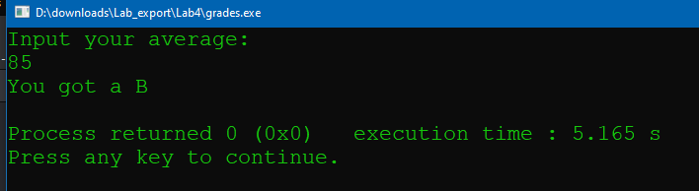

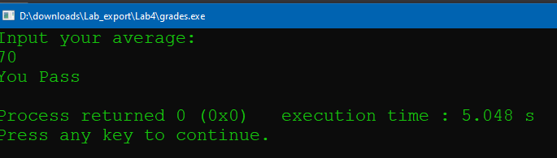

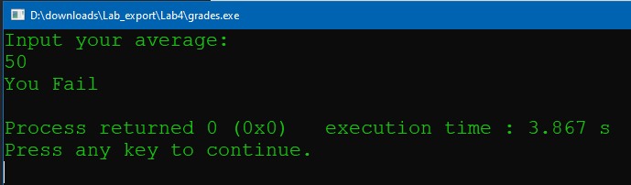

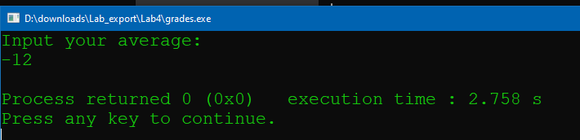

-12 returns nothing, could put it into error check

Source Code

// This program prints "You Pass" if a student's average is

// 60 or higher and prints "You Fail" otherwise

// PLACE YOUR NAME HERE

#include <iostream>

using namespace std;

int main()

{

float average; // holds the grade average

cout << "Input your average:" << endl;

cin >> average;

if (average >100)

cout<<"Invalid Input"<<endl;

else if (average >= 90 && average<=100)

cout << "You got an A" << endl;

else if (average >= 80 && average<=99)

cout << "You got a B" << endl;

else if (average >= 60 && average<=79)

cout << "You Pass" << endl;

else if (average >= 0 && average<=59)

cout << "You Fail" << endl;

return 0;

}

4.3

1.



2. You could with a else if because you can check for all other values , however it is easiest to just use the !=4 so you only have to check for that value

3.4 year students or students wit higher than or equal to a 2.0 will graduate

Else if

They haven’t been there for 4 years (even if it’s a 5th year) and their gpa is less than 2.0 they need more schooling

4. No because that would work for all other values

Source COde

// This program illustrates the use of logical operators

// PLACE YOUR NAME HERE

#include <iostream>

using namespace std;

int main()

{

char year;

float gpa;

cout << "What year student are you ?" << endl;

cout << "Enter 1 (freshman), 2 (sophomore), 3 (junior), or 4 (senior)"

<< endl << endl;

cin >> year;

cout << "Now enter your GPA" << endl;

cin >> gpa;

if (!(gpa <= 2.0) && year == '4')

cout << "It is time to graduate soon" << endl;

else if (year != '4' || gpa <2.0)

cout << "You need more schooling" << endl;

return 0;

}

4.4

1. 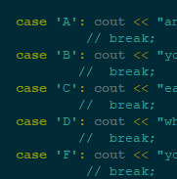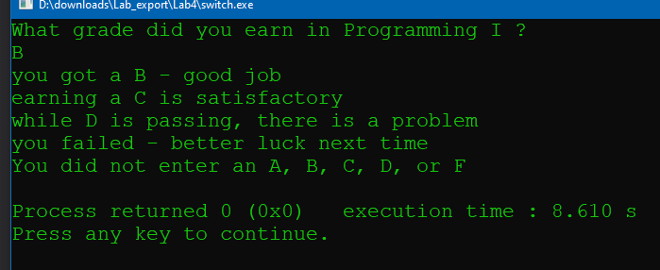

It will execute through multiple cases instead of just the one

2.

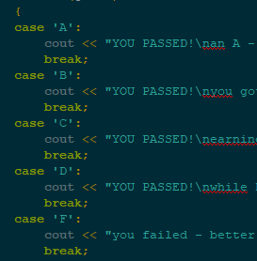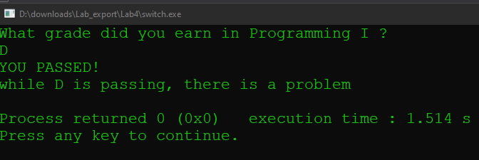

3. trailing else corresponds with the default statements

Pre change source code switch

switch (grade) // This is where the switch statement begins

{

case 'A':

cout << "YOU PASSED!\nan A - excellent work !" << endl;

break;

case 'B':

cout << "YOU PASSED!\nyou got a B - good job" << endl;

break;

case 'C':

cout << "YOU PASSED!\nearning a C is satisfactory" << endl;

break;

case 'D':

cout << "YOU PASSED!\nwhile D is passing, there is a problem" << endl;

break;

case 'F':

cout << "you failed - better luck next time" << endl;

break;

default:

cout << "You did not enter an A, B, C, D, or F" << endl;

Fully changed source code

// This program illustrates the use of the switch statement.

// PLACE YOUR NAME HERE

#include <iostream>

using namespace std;

int main()

{

char grade;

cout << "What grade did you earn in Programming I ?" << endl;

cin >> grade;

if (grade=='A')

cout << "YOU PASSED!\nan A - excellent work !" << endl;

else if(grade=='B')

cout << "YOU PASSED!\nyou got a B - good job" << endl;

else if(grade=='C')

cout << "YOU PASSED!\nearning a C is satisfactory" << endl;

else if(grade=='D')

cout << "YOU PASSED!\nwhile D is passing, there is a problem" << endl;

else if(grade=='F')

cout << "you failed - better luck next time" << endl;

else

cout << "You did not enter an A, B, C, D, or F" << endl;

return 0;

}

4.5

Option 1

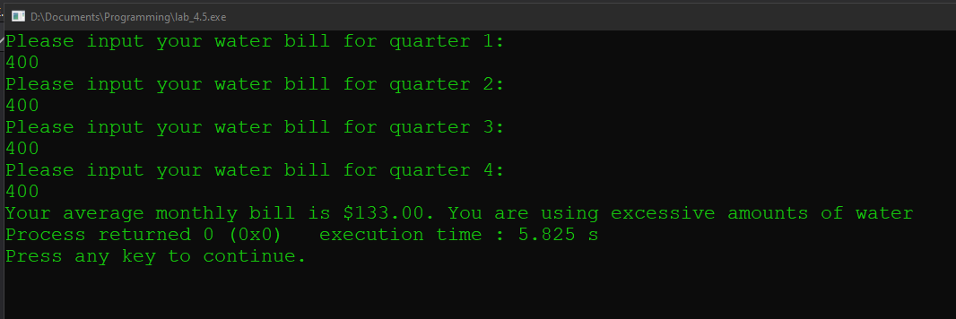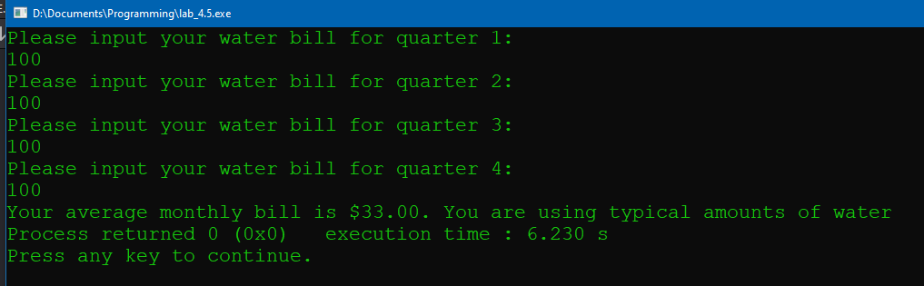

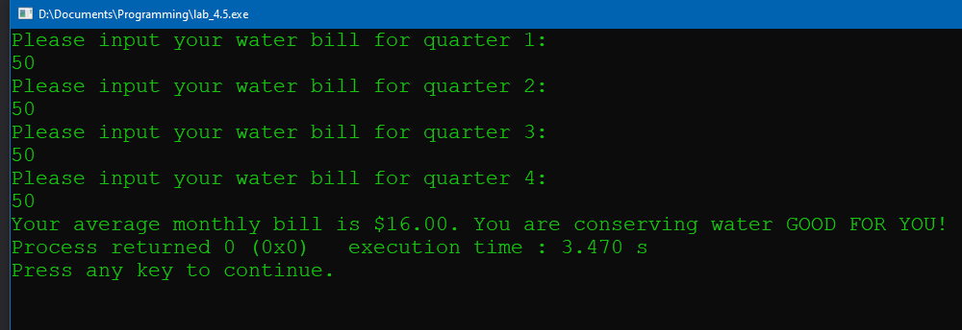

Source Code

#include <iostream>

#include <iomanip>

using namespace std;

int main()

{

int bill_1,bill_2,bill_3,bill_4;

double average;

cout <<"Please input your water bill for quarter 1:"<<endl;

cin >>bill_1;

cout <<"Please input your water bill for quarter 2:"<<endl;

cin >>bill_2;

cout <<"Please input your water bill for quarter 3:"<<endl;

cin >>bill_3;

cout <<"Please input your water bill for quarter 4:"<<endl;

cin >>bill_4;

average = (bill_1+bill_2+bill_3+bill_4)/12;

cout <<"Your average monthly bill is $"<<fixed<<setprecision(2)<<average;

if (average >75)

cout<<". You are using excessive amounts of water";

else if(average>=25 && average <=75)

cout<<". You are using typical amounts of water";

else if(average <=25)

cout<<". You are conserving water GOOD FOR YOU!"

}